Exercise 1

1. The IP address of gaia.cs.umass.edu is 128.119.245.12. It was using port 80. The IP address of client computer is 192.168.1.102. The port is 1161.

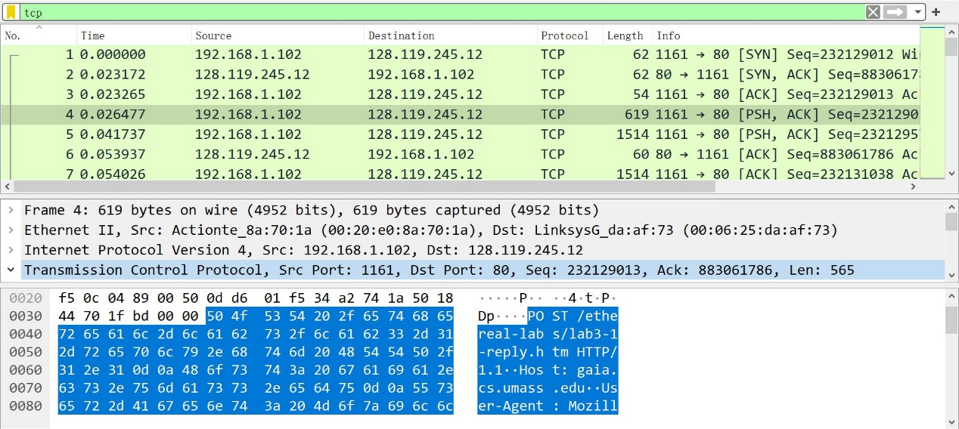

1. The sequence number is 232129013. “POST” is in the second line in data field.
2. the sequence numbers of the first six segments are 232129013, 232129578, 232121038, 232132498, 232133958 and 2321235418. The segments were sent 0.026447s, 0.041737s, 0.054026s, 0.054690s, 0.077405s and 0.078157s after starting capture. First RTT is 0.02746s. Second RTT is 0.03557s. Third RTT is 0.070059s. Forth RTT is 0.114428s. Fifth RTT is 0.139894s. Sixth RTT is 0.189645s. Estimated RTT are 0.02746s, 0.028472s, 0.033699s, 0.043790s, 0.055803s and 0.072533s.

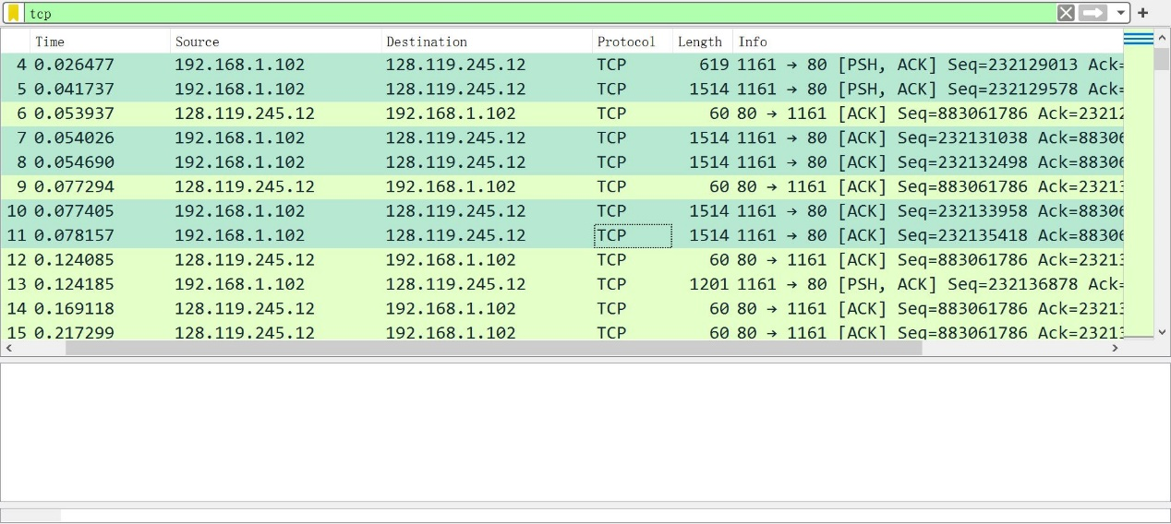

First six segments

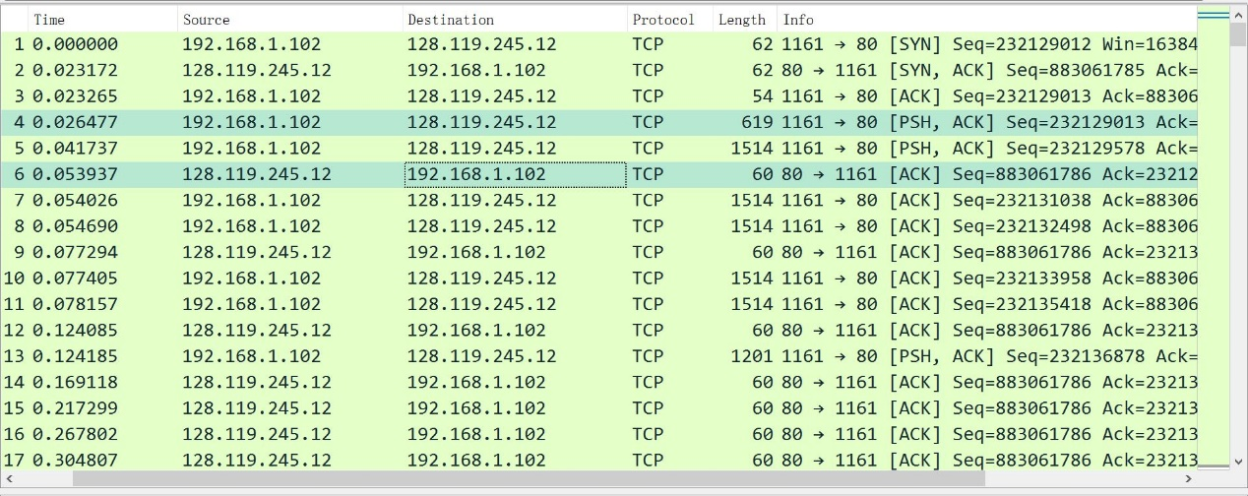

First request and ack

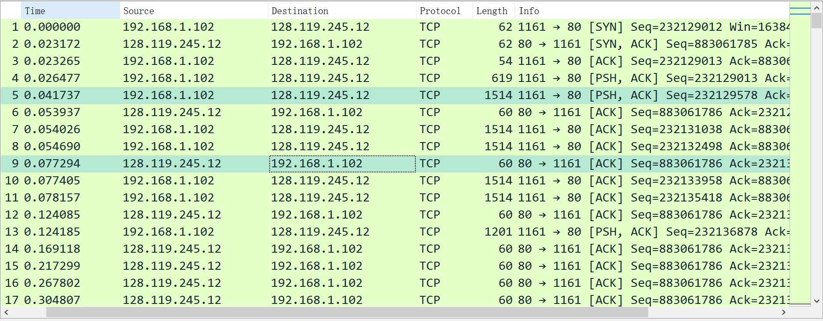

Second request and ack

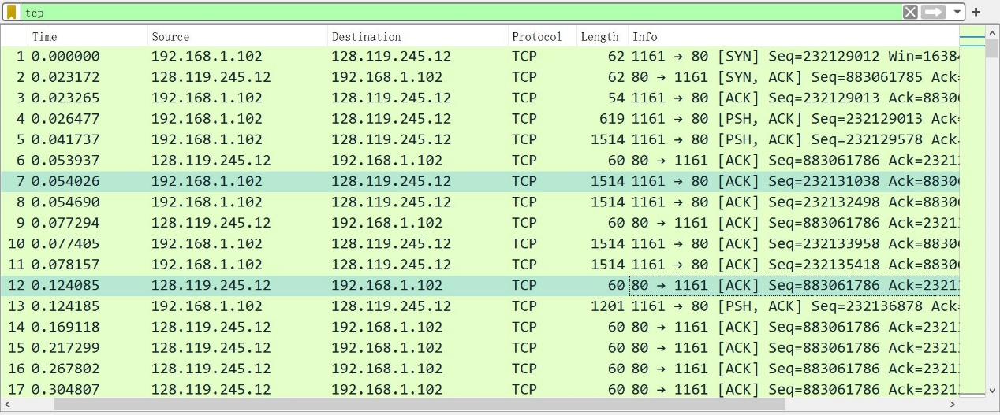

Third request and ack

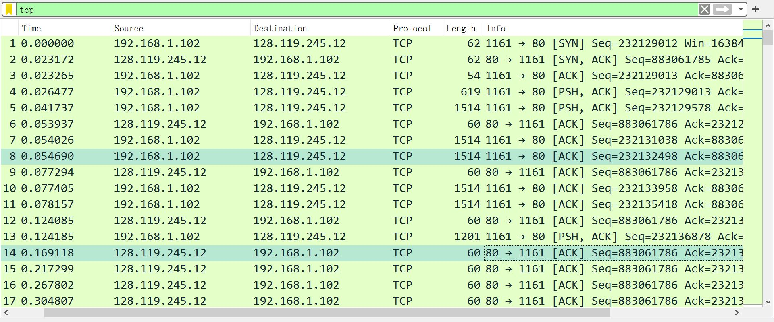

Forth request and ack

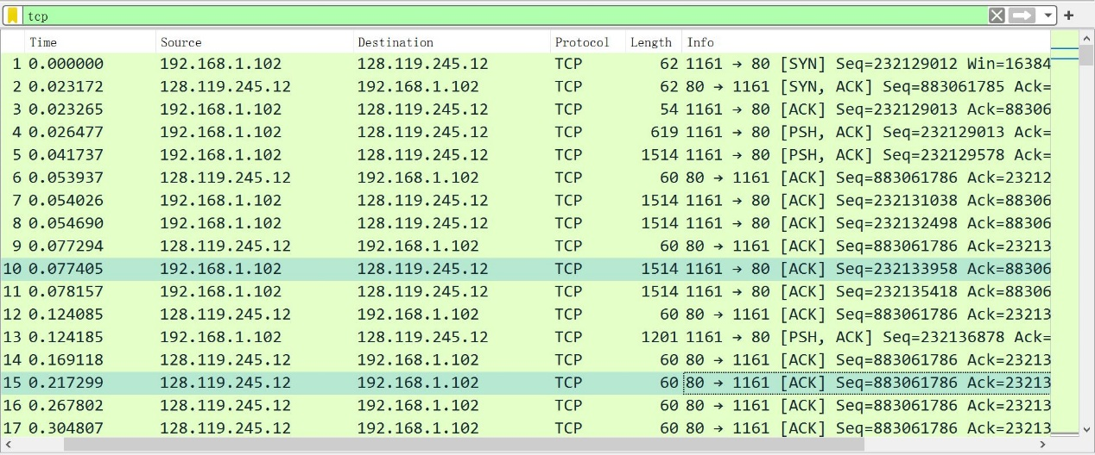

Fifth request and ack

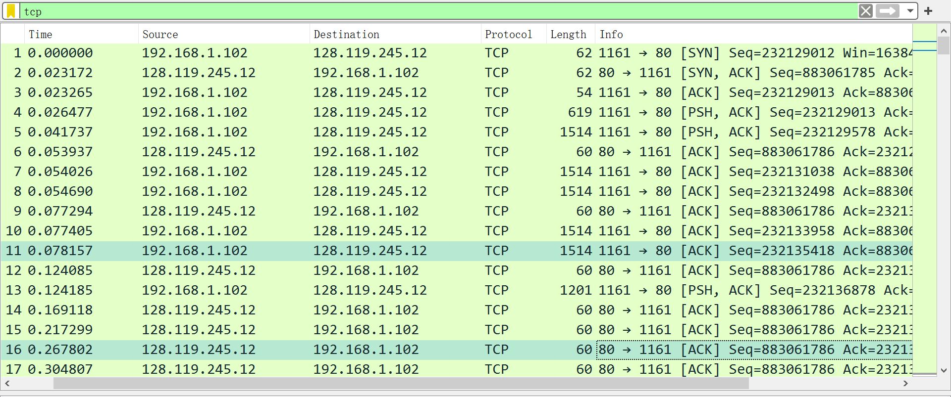

Sixth request and ack

1. The length of first TCP segment is 565 bytes. The rest of five TCP segments are 1460 bytes.

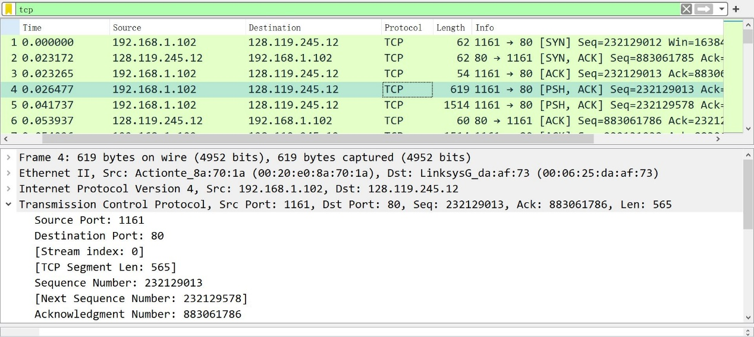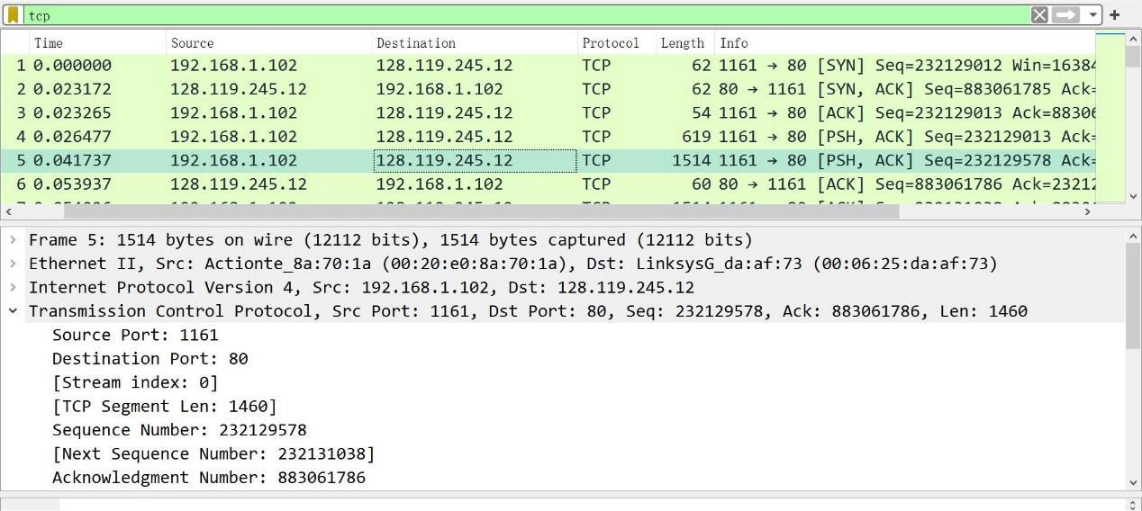

1. The minimum amount of available buffer space is 5840 bytes. While it is minimum buffer space, most of data packet sent from sender is no bigger than 2000 bytes. So it will not affect sender.

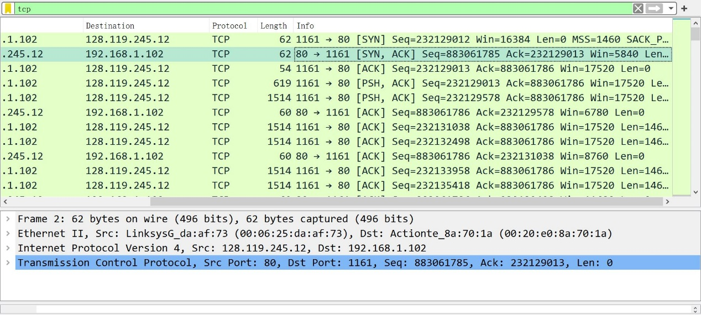

1. No. To find out it, check every ack number of responses sent from port 80 to port 1161. If any of them are same, loss of packets happened.
2. The receiver typically acknowledged 1460 bytes in an ACK. Sometimes different numbers of bytes were acknowledged. For example, the receiver acknowledged 565 bytes in sixth segment, whose corresponding segment is forth segment sending 565 bytes to the receiver. There are cases where the receiver is ACKing every other received segment. For example, segment 59 is the ACK of segment 53, which we can get from highlighting segment 59 and find a tick before segment 53. However, segment 60 is the ACK of segment 55, which means there is no ACK corresponding to segment 54. Therefore ACK 60 correspond to both segment 54 and 55.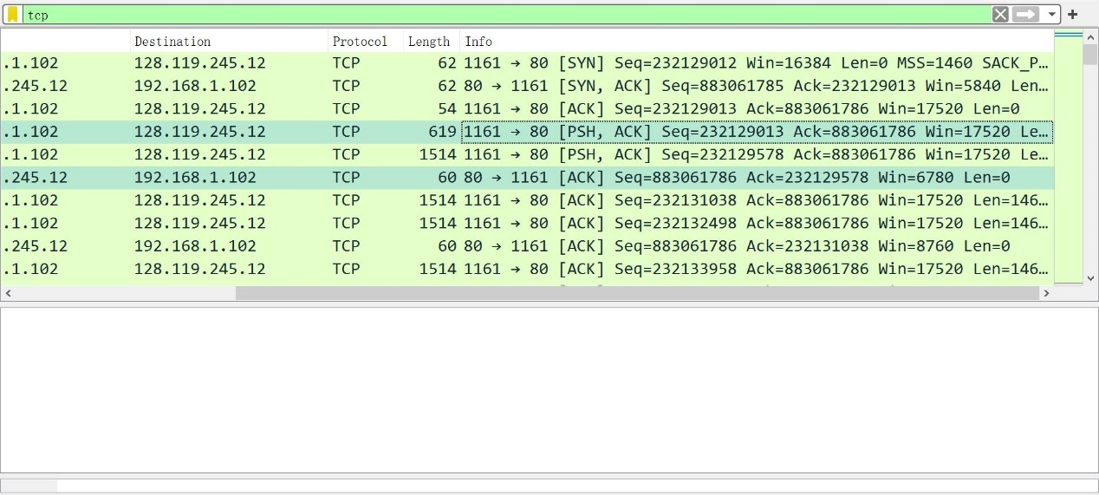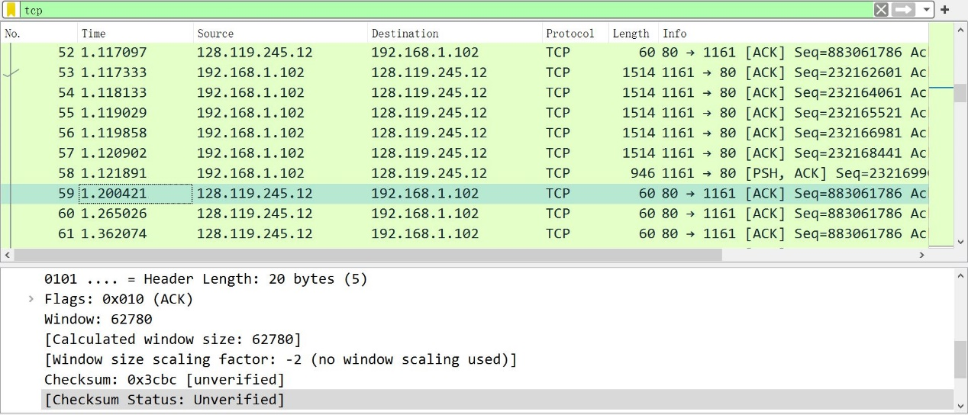

ACK 59

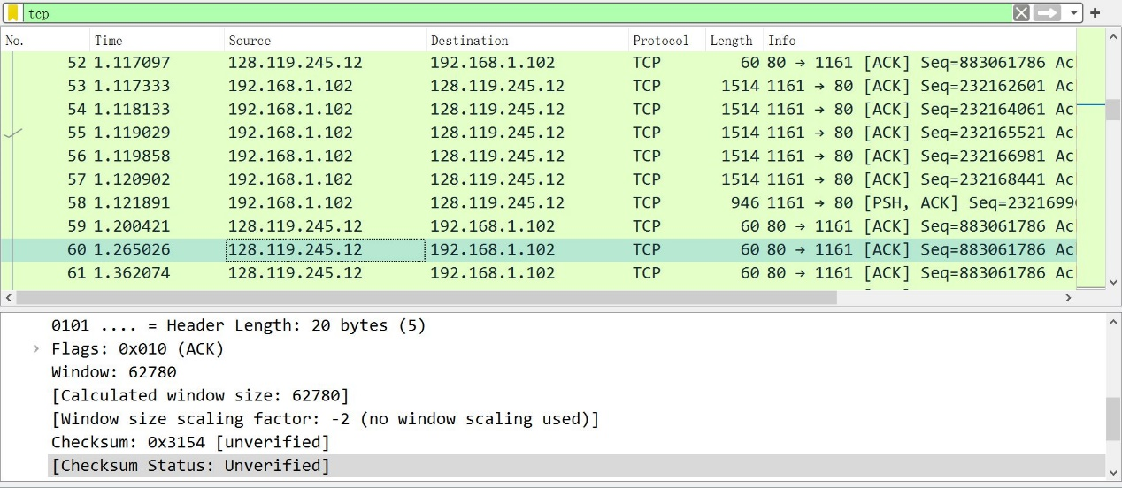

ACK 60

1. The throughput is 30222 bytes per second. To get the number, use the last ACK number that acknowledging received a TCP packet, which is sent by segment 202, to minus first sequence number, which is sent by forth segment, to get the total transferred data. 232293103-232129013=164090 bytes. To calculate time, minus the time of same two segment. 5.455830-0.026477=5.455830s. 164090/5.455830=30222 bytes per second.

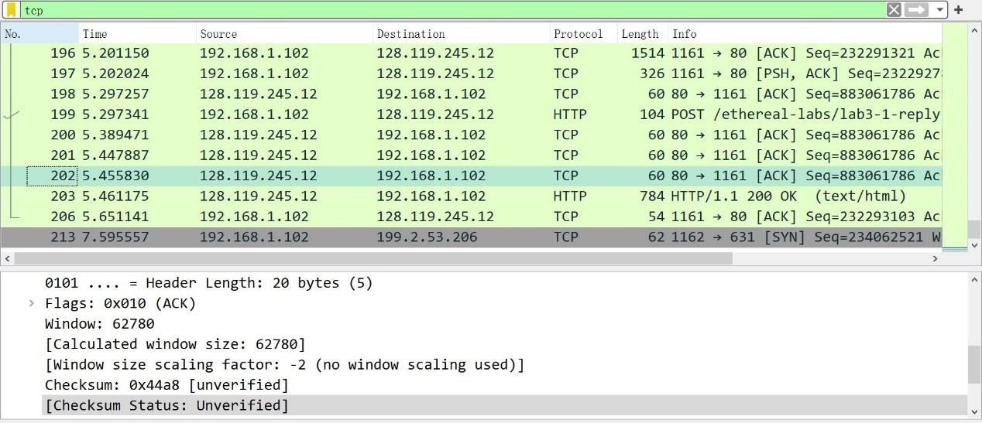

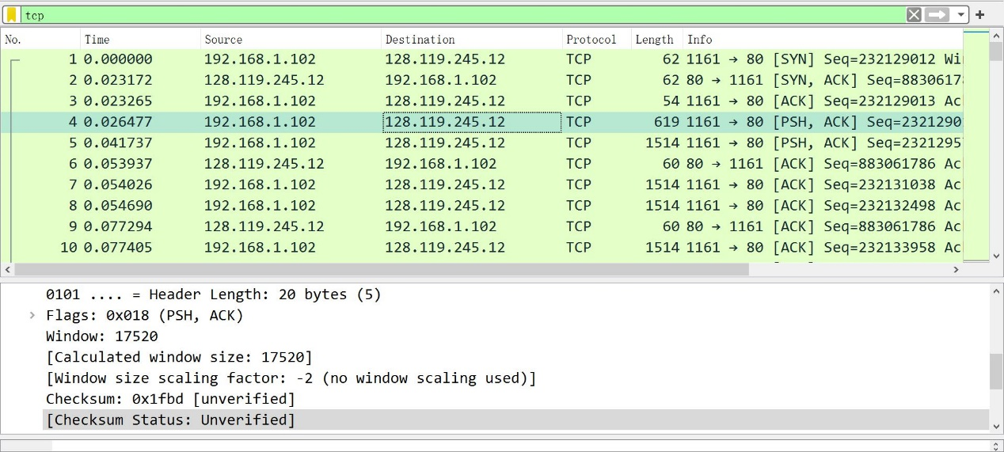

Exercise 2

1. The sequence number of the TCP SYN segment is 2818463618.
2. the sequence number of the SYNACK segment is 1247095790. The value of the Acknowledgement field in the SYNACK segment is sequence number of SYN segment plus 1, which is 2818463619.
3. the sequence number of the ACK segment sent by the client computer in response to the SYNACK is 2818463619. value of the Acknowledgment field in this ACK segment is 1247095791. It did not contain any data.
4. The client has done the active close. Because the earliest record contained FIN is sent from client. It was a 3 Segment close, since FIN and ACK are send simultaneously in segment 304, 305.
5. 35 bytes have been transferred. It can be told from the difference between the Initial Sequence Number and the final ACK received from the other side.